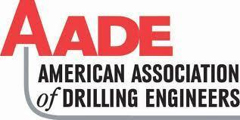

Application form for the
AADE Josh Kamas Scholarship

DEADLINE: March 29, 2023 - 11:00 a.m

Two (2) $1000 scholarships are available for undergraduate students studying Petroleum Engineering and who are active AADE members.

Criteria:
- U.S. citizen
- New Mexico Tech student: enrolled full time pursuing a B.S. in Petroleum Engineering
- Member of NMT AADE Student Chapter
- Demonstrate financial need
- 2.75 minimum GPA
- 250 word essay on “Discuss a time in your life when you showed initiative in an academic and/or professional situation. Describe how you are a self-starter.”
- Include unofficial transcript

Name:___________________________________ ID:____________ _

Address (local):_________________________________________________________________

GPA:________ Expected graduation date:____ ______

Career Interests/Goals:________________________________________________________________

______________________________________________________________________________

Clubs or Organizations involved with:_____________________________________________

______________________________________________________________________________

Current Scholarships being received for 2022-23:____________________________________

______________________________________________________________________________

Have you filed a Free Application for Federal Student Aid for 2022-23:_______
I am a full time student attending New Mexico Tech. I certify that the above information is complete and accurate to the best of my knowledge. Misrepresentation in any statement by me will be considered adequate grounds for denial or cancellation of any award. I also give my consent for New Mexico Tech to release my academic information to the scholarship donor.

_______________________________________________ _______________________
Student Signature Date

Please return completed application to: FINANCIAL AID USE
Alejandra Correa FAFSA received?___________
MSEC 300A, Petroleum Engineering NMT Scholarship?__________
alejandra.correa@nmt.edu Demonstrated Need?________

